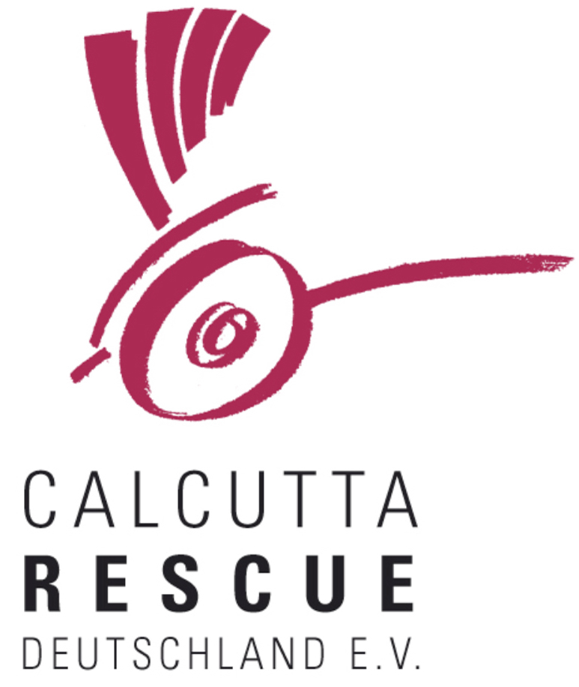
Calcutta Rescue Deutschland e.V.

Mittermayrstr. 12
80796 München
Germany
info@calcuttarescue.de
+49 800 589 0489

Project Questionnaire - Calcutta Rescue Deutschland e.V.

Application for Granting Financial Support

1.
  General information
  Title of Project
1.1
  Is this a new project or the continuation of an already existing project?
  New Already existing
1.2
  Planned duration of the project
  For which period of time is the project planned (project period)?
  For which period is funding requested from Calcutta Rescue Deutschland e.V. (funding period)?
1.3
  What are the total costs of the project?
  What is the amount requested from CR Deutschland e.V.?
  In case you request only a share of the total costs from CR Deutschland e.V.
  to which other national or international agencies have you submit a proposal?
1.4
  Contact person for CR Deutschland e.V. for this project
  Name
  Contact details (name, email ID, phone no., etc.)
1.5
  Information on the project staff
  Please complete for each person working in the project a form as follows:
  Name: | Function: | Percentage of full time position:
2.
  Rationale/reasons for the project and target group (beneficiaries) to be addressed by the planned project
  Please describe and analyse the problems (the situation) intended to be addressed through the project.
2.1
  Give detailed information on the target group/beneficiaries to be addressed by the planned project.(express in quantitative terms)
  Eligibility criteria of target group
  Number of persons, according to sex and age
  if so, the epidemiology of target disease in the target area
  Actual participation of the target group/beneficiaries in the planning process of the project and the further participation in the implementation, monitoring, and evaluation of the project
3.
  Activities planned and working methods
  Please describe in detail the activities planned.
3.1
  Working methods planned/Instruments
  Please describe the working methods planned/instruments applied to achieve project purposes.
4
  Cooperation in terms of content and finances
  Do you cooperate with other organisations (NGO, Church, Government, etc.) in this particular project? If yes: please specify.
5.
  Project Management
  How do you ensure that the activities planned are “on track” in relation to the project objective/project goal and that adjustments are made in time if conditions change?
  How does monitoring take place?
5.1
  Provide documents on Project preparation
  - a financing plan (broken down into financial years)
  - in case of a cooperation project: Please provide a statement on co-finances.
  - Please provide a financing plan (broken down into financial years)
  (Investment, operation expenditure (given in decreasing rates), personal costs (given in decreasing rates), evaluation costs, inflatory costs, unavoidable additional expenses (if >3.5 % of project expenditure), plan of receipts, financial contribution from others, provide documents)
  enclosed yes no
  - Please provide a statement on co-finances, which is in agreement with the finance plan and which is signed and stamped by a responsible legal person of all partners.
  enclosed yes no
5.2
  Internal evaluation
  Are there internal evaluation mechanisms? If so, please describe.
5.3
  External evaluation of the project
  Is an external evaluation of the project envisaged? If so, when?
6.
  Signature and date

7.0
  Objectives/goals and indicators
  Logical Framework
   | Objectively verifiable indicator | Means of verification | Assumptions, Risks
  Goal
  Purpose
  Outputs
  Activities
  The logical framework is a 4 by 3 matrix in which designers outline how a proposed project or program will logically lead to a defined goal.
  Goal: overall program objective
  Purpose (or objective): describes what the program is supposed to achieve or the expected measurable result of its implementation
  Outputs (or results): describes what the program will do in order to achieve its purpose
  Activities: need to be carried out to achieve the program outputs (linked to each output)
  Please define separately the overall objective/overall goal the project aims to contribute to. (Desired situation on completion of the project.)

